Security Design Review Report

# Revision

Version 1

1/18/22 1:50 PM

# SME

Charles Wilson

# Abstract

This document describes the process to create a security design review report and information contained within it.

# Group / Owner

Security / Systems Requirements Planner

# Motivation

This document is motivated by the need to have traceability of the certification work products required for the certification of safety-critical, cyber-physical systems, such as ISO 21434 and 26262. Specifically, we need to document the outcomes of the review of the design process to determine the security deficiencies of the element being reviewed.

# License

This work was created by **Motional** and is licensed under the **Creative Commons Attribution-Share Alike (CC BY-SA-4.0)** License.

[**https://creativecommons.org/licenses/by/4.0/legalcode**](https://creativecommons.org/licenses/by/4.0/legalcode)

# Overview

The **Security Design Review Report** captures the security deficiencies discovered during the security design analysis **[1]** process. This report is used to ensure that those discoveries are properly disposed.

The following diagram illustrates the process to be used:

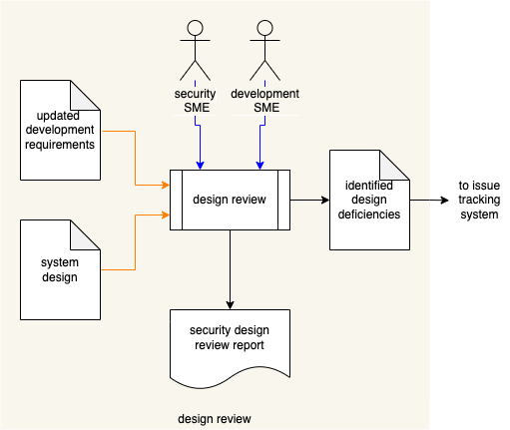

# Process

## Design Review

|  |  |
| --- | --- |
| Inputs | system design  updated development requirements |
| Outputs | identified design deficiencies |
| Participants | Security SME  Development SME |

A **Development SME**, working in conjunction with a **Security SME**, will review the system’s design based on the updated development requirements established in the activities described in **Design Showing Security Considerations** **[1]**. The **Security SME** will generate a **Security Design Report**. If deficiencies are identified, these will be enumerated and entered into the issue tracking system for remediation.

### Design Review Report

The design review report should detail the security deficiencies exposed during the design review. The report should be organized into summary and details sections. The summary includes:

* Description of the system
* Image of the system (typically a DFD)

The details section contains one or more diagrams. Each of these is organized into summary and data flow sections. The summary includes:

* Diagram title (unique)
* Description of the diagram’s scope
* Image of the diagram

Individual data flows are used to organize the individual deficiencies. Each of these is organized into a summary and deficiency list. The summary includes:

* Data flow ID (unique)
* Source of the data flow (originator)
* Destination of the data flow (recipient)
* Description of the data flow (payload)
* Image of the data flow in isolation

Individual deficiencies include:

* ID (unique)
* Category (from the security requirements taxonomy)
* Security requirement not being satisfied (from the updated development requirements)
* Summary of the deficiency
* Detailed description of the deficiency
* Recommendation for remediation

It is recommended that the report be generated from a portable data representation so that it can be programmatically manipulated.

# References

1. **Design Showing Security Considerations** (AVCDL secondary document)
2. **Security Requirements Taxonomy** (AVCDL secondary document)